**Task10-Gemnini**

**CSS Box Model and Its Components**

The CSS box model is a conceptual representation of how elements are laid out on a web page. It consists of four main components:

1. **Content:** The actual content of the element, such as text or images.
2. **Padding:** The space between the content and the border.
3. **Border:** The outline or edge of the element.
4. **Margin:** The space outside the border, separating the element from neighboring elements.

The box model can be visualized as a nested structure, where each element is contained within a box. The width and height of an element are determined by the sum of its content, padding, border, and margin.

**Example HTML Layout and CSS Styling**

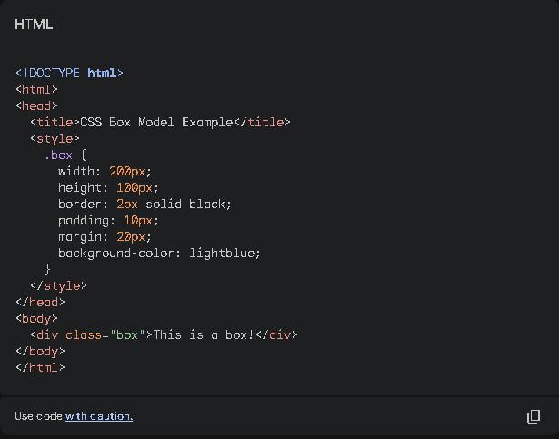

**Result :**

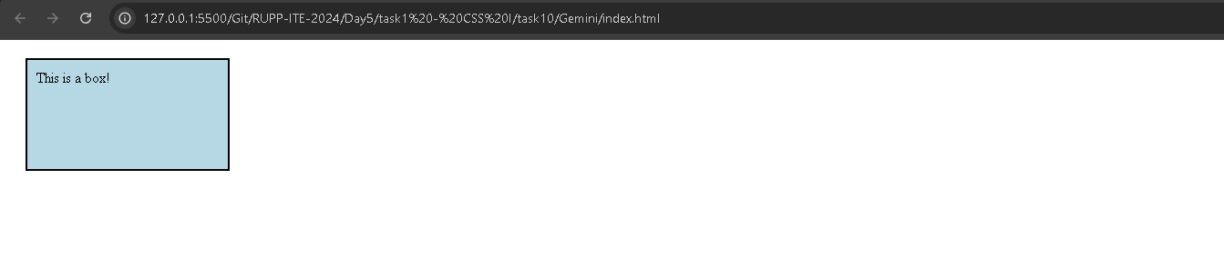

This code creates a simple div element with the class "box" and applies the following styles:

* **Width and height:** Sets the dimensions of the box.
* **Border:** Adds a 2-pixel solid black border.
* **Padding:** Creates a 10-pixel space between the content and the border.
* **Margin:** Adds a 20-pixel space between the box and its neighboring elements.